Catney Christmas Craft Fair
Village Hall, Saturday 27th November 2021; 11am to 3pm

Last year the winter lockdown meant that our annual Catney Christmas Craft Fair had to be cancelled. At the moment we plan to hold a fair this year unless there is a major change in the rules.
To keep us as safe as possible, the fair will be a bit different in that the tables will be more spaced out with some stalls outside in the space at the back of the hall. We ask that customers wear a mask inside unless sitting at a table [similar to the rules in pubs and restaurants]. Although the major risk of infection is through breathing in virus, some of the stall holders may ask you to sanitise your hands begore ‘handling the goods’.
We will have the usual mixture of handmade craft goods, including stained and fused glass, boxed pictures, garden planters made from recycled wood, fabric and knitted goods, Christmas decorations, gifts, toys and home-made preserves and some new and novelty items.
Once again, we shall serve tea, coffee, and homemade cakes. Can those who can help provide some home baking contact Lesley Cuthbert on 07776 480813 or by email at cuthbertlm@me.com
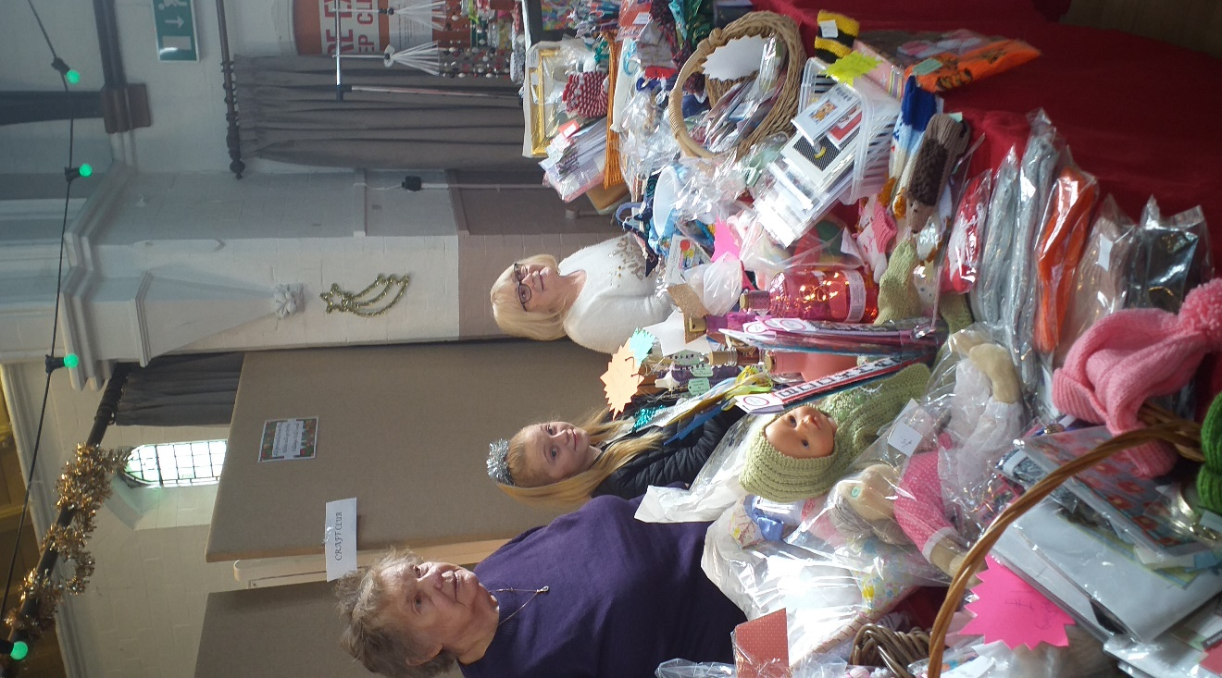
If there are any people who are new to the village and have some craft skills and would like some space, particularly if you are willing to use some outside space, please contact me soon on liz@boxall.info or text to 07939 073416 to express an interest.
We hope you will all come along on the day and support and enjoy our major village social event.
A view of the craft club table from 2019

