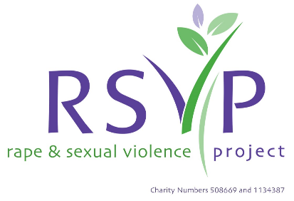

**Bite Size Training Sessions at RSVP:**

The Rape and Sexual Violence Project (RSVP) specialist training team would like to invite you to attend our ‘Bite Size Training Sessions’ which will be held throughout 2022 on a variety of subjects related to supporting survivors of sexual violence and abuse. All training sessions are 2-hour interactive on-line sessions via Zoom.

**If you would like to book a place onto any of these sessions follow this link:**

<https://www.eventbrite.co.uk/o/rsvp-29690469567>

**Alternatively, if you would like to buy tickets via BACS payment, please contact the training team directly at** [**trainer@rsvporg.co.uk**](mailto:trainer@rsvporg.co.uk)

**Each session is £25 per participant**

|  |  |  |
| --- | --- | --- |
| **Title** | **Overview** | **Date** |
| Supporting survivors of sexual violence and abuse | Explore ways of safely supporting survivors of sexual violence and abuse in a trauma responsive way. | Wednesday 5th January 10am-12pm |
| Male survivors of sexual violence and abuse | Exploring the lack of awareness and silencing of male survivors, and ways of supporting male survivors of sexual violence and abuse. | Tuesday 11th January 10am-12pm |
| Understanding the rise in image-based abuse | Examining the rise in sexual violence perpetrated using technology and the internet. Including discussion of the influence of hyper-sexualised media and online pornography and the impact of image-based abuse on survivors. | Thursday 13th January 10am-12pm |
| Understanding short term support through a trauma informed lens | Exploring how we manage expectations of ourselves and our clients with short term support. Examining how we can facilitate feelings of safety in the short term. | Monday 17th January 10am-12pm |
| Reflecting on the principles of trauma informed practice | Breaking down the core principles of trauma informed approaches and examining each element. Focusing on physical space, emotional safety, coping mechanisms, empowerment, building positive relationships and cultural difference and identity. | Tuesday 25th January 10am-12pm |
| An Introduction to Trauma-Informed Practice | Examining the physical and emotional impact of trauma and the basic principles of ‘trauma-informed’ practice. | Tuesday 1st February 10am-12pm |
| Becoming Trauma Responsive | Moving on from being ‘Trauma-Informed’, this session will go deeper in exploring the brain and body’s responses to trauma and how practitioners can support survivors in a trauma-responsive way. | Wednesday 9th February 10am-12pm |

The sessions are suitable for practitioners working in a variety of sectors who engage with adults, young people, and children. The aims of the sessions are to broaden your knowledge and skills in relation to the impact of sexual violence, trauma and abuse. They will equip you with knowledge of how best to support survivors of sexual violence whether they are colleagues, staff or service users.

**If you have any questions about the Bite Size sessions or would like any further information about bespoke training offers, please contact the training team at** [**trainer@rsvporg.co.uk**](mailto:trainer@rsvporg.co.uk)

**Feedback from participants:**

*“Really thought provoking, has made me question some of my responses, see where as an organisation we can adjust the language we use, etc.”*

*“Well-presented and knowledgeable trainer. Will certainly be looking at attending other training modules and CPD with you.”*

*“It was very informative – no improvements needed. Delivery was clear and concise.”*

*“Delivery was excellent. The trainer is calm and clear and holds the space really nicely. There was a good balance between letting us interrupt with questions and listening. It flowed well.”*

*“Really enjoyed it. Found it to be a great balance of practical advice, challenging misconceptions, and guidance towards resources and further academic research to continue learning in the longer term. Great facilitation of group discussion. Given the diversity of people attending (and their reasons for doing so), this session still did well at meeting each of our needs.”*