National Highways
2 Colmore Square
38 Colmore Circus
Birmingham
B4 6BN



Dear Homeowner

M42 junction 6 Improvements

We’re writing to give you an update on the construction of the new M42 junction 5a, part of our upgrade scheme on the M42 at junction 6. We recently opened the new bridge on Catherine de Barnes Lane connecting St Peters Lane North with Catherine de Barnes Lane on 10 February. This bridge will span the new link road (A4545) running from the new junction 5a to Clock Interchange.
What’s happening next?
To allow us to continue work on the dual carriageway, Catherine de Barnes Lane (North) will be closed from 9.30am to 3.30pm on Sunday May 14. So we can remove the concrete block barriers currently in place along the edges of the Bridge. These concrete barriers have been put in place to protect vehicles and pedestrians on the bridge while permanent steel vehicle restraint barriers have now been installed.

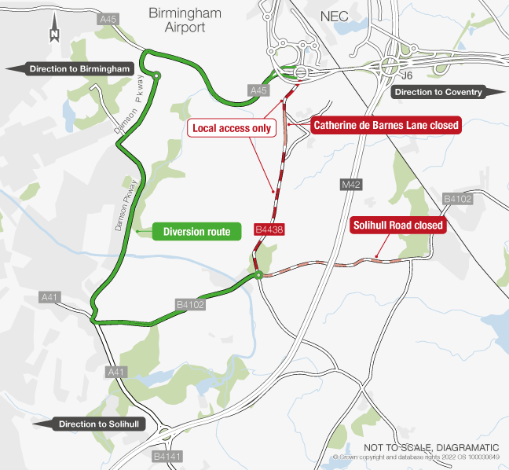
When roads are closed, we’ll put in place a clearly signed diversion route (shown above) which has been agreed with Solihull Metropolitan Borough Council as the most suitable route for both the amount and type of traffic being diverted.

Why is this road closure needed?

Safety is our primary imperative. As a result, due to the size of the machinery needed to lift the concrete blocks, a full road closure is required.

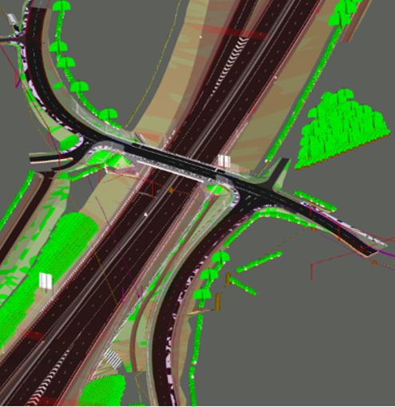
We will make every effort to manage and minimise the disruption to the local area, and we apologise in advance for any inconvenience you may experience during our upcoming work. Every effort will be made to complete this work as soon as possible.
If you have any questions about this work, or if you’d like to receive regular updates about the project, you can email me at: patrick.thomson@skanska.co.uk.

Alternatively, please visit the National Highways project webpage where you can sign up for email updates: https://nationalhighways.co.uk/our-work/west-midlands/m42-junction6/.

Yours faithfully

Patrick Thomson
Stakeholder, Customer & Communications Manager
Skanska

